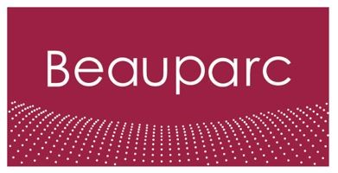

|  |  |
| --- | --- |
| **Job Title** | National Business Development Manager |
| **Reports to** | Head of UK Sales C&D |
| **Business/Function** | Sales |

|  |
| --- |
| **Purpose**  We are seeking a dynamic and driven individual to join our sales team as a National Business Development Manager. This role involves managing and developing business opportunities, growing the sales territory, and contributing to the overall development of the company. |

|  |
| --- |
| **Key accountabilities**   * Proactively and reactively sell profitable new business to meet and exceed set targets. * Manage and grow a sales territory, ensuring business retention and development of existing customer accounts. * Build and maintain strong, long-lasting customer relationships, acting as the primary point of contact between the company and our customers. * Liaise directly with the management team across the business from depot level upwards. * Oversee the timely and successful delivery of company solutions according to customer needs and objectives. * Collaborate with the Head of Brokerage UK to identify new business opportunities and ensure growth attainment. * Conduct account planning review meetings and report progress to line management. * Maintain accurate, current, and up-to-date account records. * Handle sales prospecting and pricing negotiations across your territory. * Work closely with the Brokering and Customer Service teams to ensure customer satisfaction and problem resolution. * Perform reasonable ad-hoc duties as required. |

|  |
| --- |
| **Experience**   * Proven track record in sales, particularly in selling contracted services. * Passion for sales with a history of consistently overachieving targets. * Strong background in new business sales and account management. * Background knowledge of the waste industry is desirable * Excellent communication and negotiation skills. * Ability to monitor competitor activity and adapt strategies accordingly. * Strong organisational skills with the ability to manage multiple tasks and priorities. |

*Beauparc aims to attract and retain a skilled and diverse workforce that best represents the talent available in the communities in which our assets are located and our employees reside.*

*(DE&I Policy Statement)*