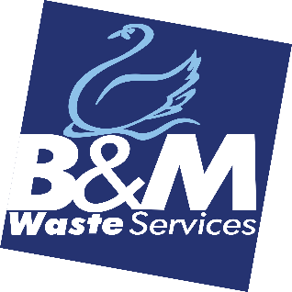B&M Waste Services

**ROLE PROFILE**: Customer Services Advisor

**LOCATION:** Bromborough

**WORKING HOURS**: 8.30am – 5pm

**REPORTING TO**: Head of Customer Services

**About**

B&M Waste Services is a customer centric, forward-thinking waste and recycling solutions provider with depots located on the Wirral, Manchester, Leeds and Birmingham. We’re an award-winning Carbon Neutral business and a member of the Beauparc group of companies.  We’re seeking a talented, hardworking and ambitious Customer Service Advisor to help us grow our business. The company's mission is to be the leading independent provider of commercial waste services in our chosen conurbations. To achieve this by dynamic growth and exceptional customer service. With a workforce who are responsive, customer focused and are Right First Time in their work.

**The Role**

To ensure all incoming calls are dealt with in a timely and efficient manner and that customer relationships are strengthened and customer experience enhanced. dynamic growth and exceptional customer service.  With a workforce who are responsive, customer-focused and are Right First Time in their work.

**Duties and Responsibilities**

* To ensure inbound and outbound calls are dealt with efficiently and professionally.
* Be able to Identify customers needs, clarify information, research every issue and help provide solutions.
* Build sustainable relationships and engage customers by taking the extra mile.
* To log all customer queries on the CRM System
* Be able to navigate our inhouse systems CRM and AMCS effiecently
* To work with internal departments in resolving customer queries.
* To assist with general admin duties including reception duties
* Proactively contact new customers after their first 6 weeks to introduce our other services.

**Skills and Experience**

* Excellent telephone manner and extremely customer focused.
* Experience within a Customer Services environment
* Good communication skills
* Knowledge of the Waste Industry would be an advantage
* Conversant in the use of Microsoft Office applications.
* Good level of written and oral communication.
* Ability to deal with people at all levels

**Personal Profile**

* Be well presented with a confident and professional manner
* Be able to work under pressure whilst remaining calm and resilient
* Be able to take the initiative and possess a "can do" attitude
* Be a Team player
* Be enthusiastic and a quick learner.

**Company Info**

* The Health, Safety and Wellbeing of our employees is very important to us.
* It is your responsibility to take reasonable care of your own and other people’s Health and Safety and must cooperate with us on Health and Safety matters.
* You will represent the company in a professional capacity at all times.