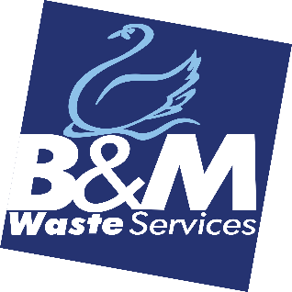JOB DESCRIPTION

**JOB TITLE**…………………… Customer Relations & Loyalty Advisor

**DEPARTMENT**……………. Customer Relations

**LOCATION**…………………. Bromborough

**REPORTING TO**…………. Customer Relations & Loyalty Manager

We’re on an exciting growth journey where the service we provide is at the heart of what drives our success. In this role you’ll join the Customer Relations and Loyalty team where you’ll play a key part in keeping our customers satisfied. You’ll work closely with customers to understand their needs, resolve concerns and implement strategies to deepen relationships and engagement. If a customer is thinking of leaving us, you’ll work your magic to remind customers of the best parts of working with us to reduce churn and keep customers with us for the long term. You’ll also be proactive and suggest changes to customers account to ensure we’re offering the right services for their need on an ongoing basis.

**MAIN TASKS AND ACTIVITIES**

1. To build strong customer relationships to deepen engagement and reduce cancellations
2. To provide excellent customer service and ensure all queries are managed in an efficient and professional way
3. Engage with at-risk customers via phone or email to understand their concerns and offer tailored solutions
4. To implement Retention strategies and put in place tailored offers to retain customers with us for the long term.
5. Collaborate with Customer Service, Service Delivery, Telesales and other Teams within the business to enhance the overall Customer Journey
6. Maintain accurate records of Customer interactions and information using our CRM system.
7. To share the voice of the customer internally, or through data, to identify common trends and provide insights to improve retention efforts
8. Help increase cross-selling opportunities to engage the customer base i.e. Simpler Recycling legislation, Heavy Bins, Confidential waste, Additional sites as well as tender opportunities
9. Initiate follow-up contact 6 weeks after agreement signing to check in on the Customer Experience
10. Maintain up to date Customer contracts and documentation as needed
11. Maintain an excellent knowledge of company service offering and the waste management industry. Whilst also being curious and responsive to changes within the sectors/markets of our customers

**SKILLS AND EXPERIENCE**

1. Experience in a customer Service or Retention focused role
2. Excellent communication and interpersonal skills
3. Ability to handle objections, negotiate and build rapport quickly
4. Strong Problem-solving skills and a Customer-first mindset
5. Highly organised with good time management skills
6. Ability to deal with people at all levels
7. The desire to win