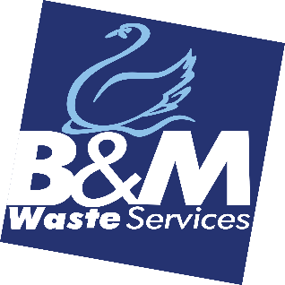JOB DESCRIPTION

**JOB TITLE**…………………… Desk Account Manager

**DEPARTMENT**……………. Customer Relations - Retentions

**LOCATION**…………………. Bromborough

**REPORTING TO**…………. Account Manager Team Leader

ROLE…………………………. To ensure all Customer queries are dealt with in a timely and efficient manner and that customer relationships are strengthened and customer experience enhanced.

MAIN PURPOSE OF THE JOB

To ensure all incoming calls are dealt with in a timely and efficient manner and that customer relationships are strengthened and customer experience enhanced. The company's mission is to be the leading independent provider of commercial waste services in our chosen conurbations.  To achieve this by dynamic growth and exceptional customer service.  With a workforce who are responsive, customer-focused and are Right First Time in their work.

**MAIN TASKS AND ACTIVITIES**

1. To ensure incoming telephone calls are dealt with efficiently and professionally.
2. To log all customer communications on the CRM System
3. Discussing and completing Contractual amendments for customers relating to changes in services.
4. To work with internal departments in resolving customer queries.
5. Any other reasonable task as may be required from time to time.
6. Help design, implementation and maintenance of a set of comprehensive policies and procedures. Post call new business cancellations, BDM leaves call their most recent customers, to provide the one-month phone call, sited dates
7. Introduce call plans to all bronze customers ( below £10k)
8. Help increase cross-selling opportunities to engage the customer base. Food, glass for heavy bins, shredding, referrals, additional sites, tender opportunities
9. Proactively contact new customers after their first 6 weeks to introduce our other services.
10. To ensure that all contracts and paperwork are updated as required.
11. Maintain an excellent knowledge of company service offering and the waste management industry as a whole as well as being responsive to changes within the sectors/markets of our customers.
12. General Reception duties including meeting and greeting visitors.
13. Directly responsible for effective customer contact to stop them from cancelling their contracts with the company.
14. Review and Resolve any price increase queries effectively and directly with Customers.

**SKILLS AND EXPERIENCE**

1. Excellent telephone manner and extremely customer focused.
2. Experience within a Customer Services environment
3. Good communication skills
4. Conversant in the use of Microsoft Office applications.
5. Good level of written and oral communication.
6. Ability to deal with people at all levels

**PERSONAL PROFILE**

1. Be well presented with a confident and professional manner
2. Be able to work under pressure whilst remaining calm and resilient
3. Be able to take the initiative and possess a "can do" attitude
4. Be a Team player
5. Be enthusiastic and a quick learner.

I confirm that I have instructed the below signed in the above.

CR Manager’s Signature: _______________________________

date: ____/____/____

I confirm that I have been instructed in and understand the above. I also understand the above forms part of my terms and conditions.

Employee Name_________________________________________Signature________________

date: ____/____/____