JOB DESCRIPTION 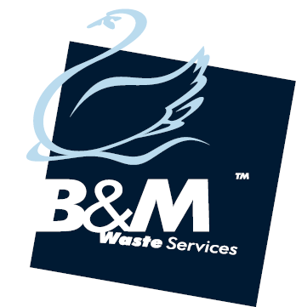

**JOB TITLE**…………………… National Operations Supervisor

**DEPARTMENT**……………. Service

**REPORTING TO**…………. Service Delivery Manager

**ROLE**…………………………. To plan, organise and manage the daily work of the office. To support the Service Leadership team in a positive and proactive manner. To ensure all tasks are completed in line with the companies Health and Safety Policy and in a Profitable manner.

The company's mission is to be the leading provider of commercial waste services in our chosen conurbations.  To achieve this by dynamic growth and exceptional customer service.  With a workforce who are responsive, customer focused and are Right First Time in their work.

**MAIN PURPOSE OF THE JOB**

1. To ensure all work is carried out maintaining high levels of customer service.
2. To ensure high levels of Health and Safety are observed.
3. Ensure all jobs undertaken are done so ensuring profitability.
4. To ensure all data input is accurate and completed in a timely manner.

**MAIN TASKS AND ACTIVITIES**

1. To be responsible for the day to day activities of the team.
2. Under the Service Delivery Manager enforce standards of discipline and control and assist with the induction of new members.
3. Answer incoming calls and deal with all enquiries effectively and efficiently, logging cases where necessary.
4. Be the first point of contact for escalations.
5. Complete QCs and case audits.
6. Lead huddles as and when required.
7. Driving compliance – ensuring the team hits 96% SLA compliance each month.
8. Prioritising work schedules to maximise efficient work.
9. Ensure all customer enquiries are responded to quickly and positively.
10. Proactively look into missed collections and resolve any issues.
11. Respond to and log on CRM any customer complaints and resolve in a timely manner.
12. Ensure the Hotlist is kept up to date and any service issues relating to these customers are communicated to them in a timely manner.
13. Any other reasonable task as may be required from time to time.

**SKILLS AND EXPERIENCE**

1. Good leadership skills
2. Customer Service
3. Extensive knowledge of the waste industry
4. Competent in the use of Microsoft applications

**PERSONAL PROFILE**

1. Tenacious and resilient
2. Flexible
3. Diligent
4. Team Player
5. Leader
6. Able to work on own initiative.

I confirm that I have instructed the below signed in the above.

Service Delivery Manager:__________________________Signature___________________________

Date: ____/____/____

I confirm that I have been instructed in and understand the above. I also understand the above forms part of my terms and conditions.

Employee Name:______________________________Signature_____________________________

Date: ____/____/____